**FACEBOOK PAGE CLONE PHISING WEBSITE**

* Launch the social engineering app from applications tab in kali linux
* “SET”
* 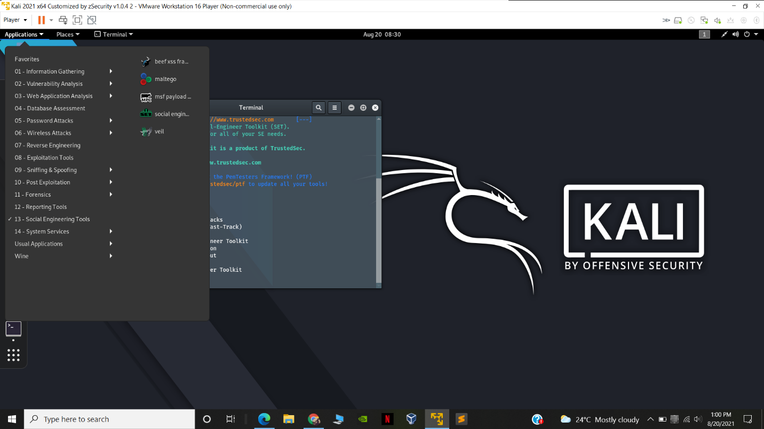

-terminal wil get opened

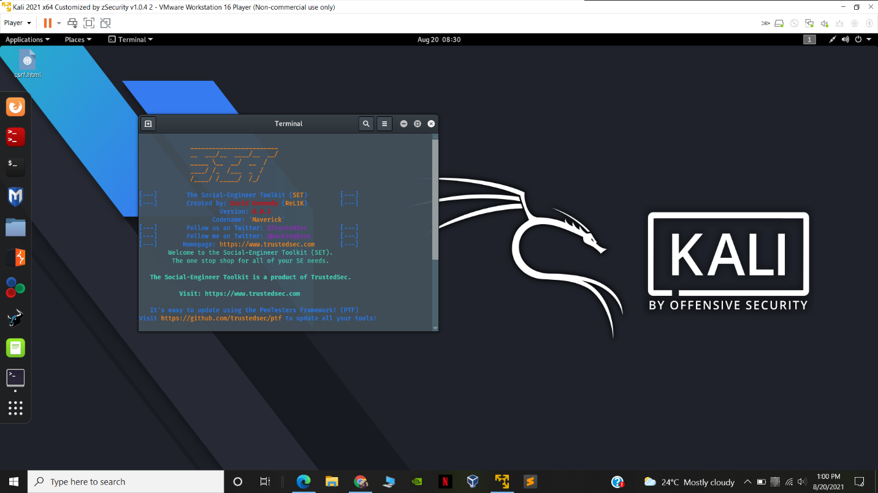

* Type 1 and hit enter as we want social engineering attack
* Then type 2 and hit enter as we want website attack

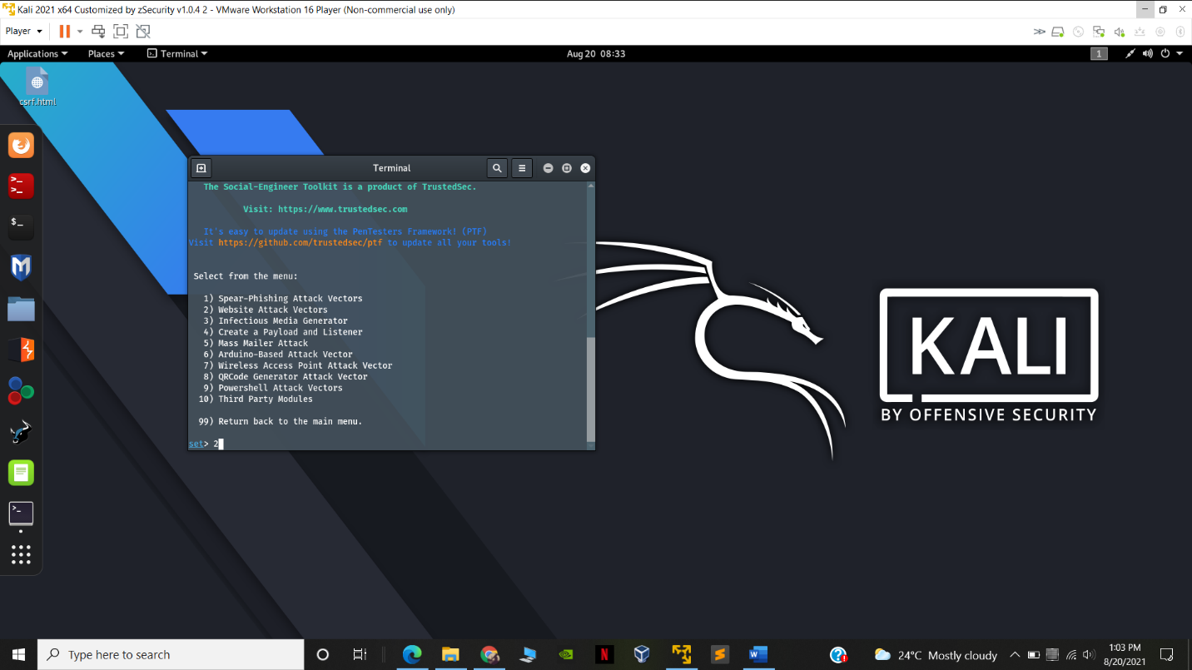

-then type 3 and enter as we want credential harvestor

(he Credential Harvester method will utilize web cloning of a web- site that has a username and password field and harvest all the information posted to the website.)

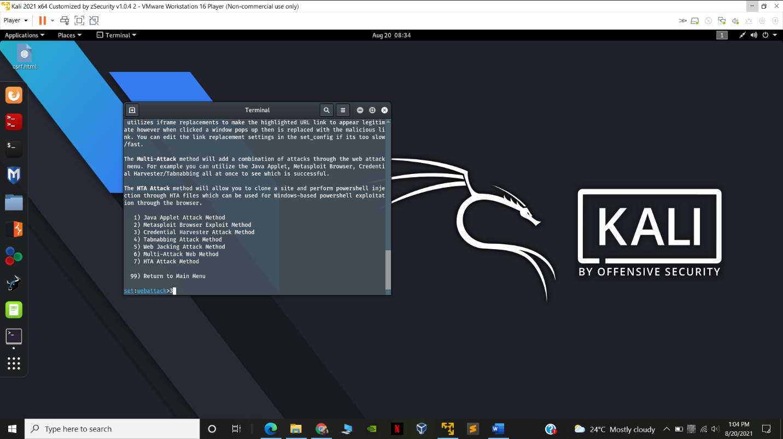

-then type 2 we will clone an existing website

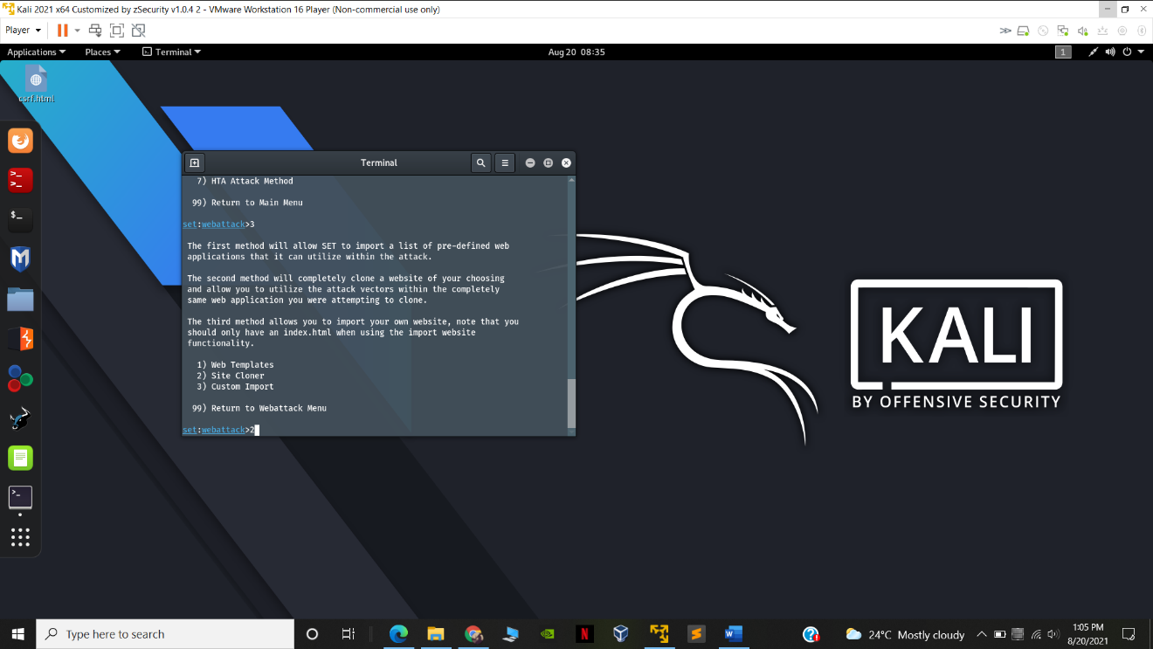

-then type ip address of the server where we want to host the clone we will use kali linux own ip address server (192.168.1.3)

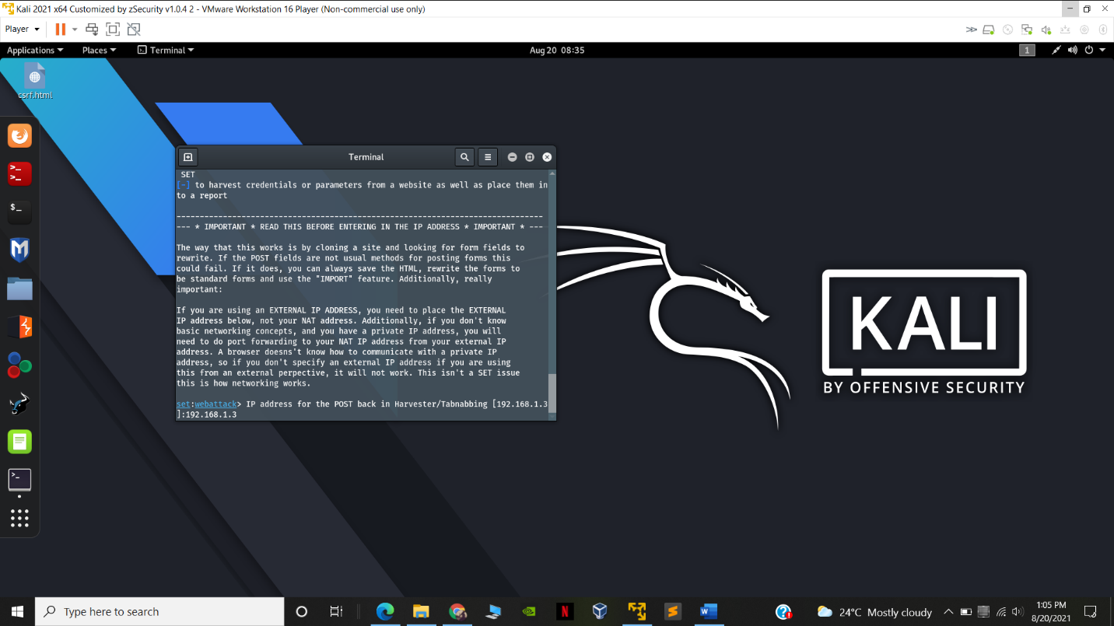

-then type the url of the website u want the clone (<https://facebook.com>)

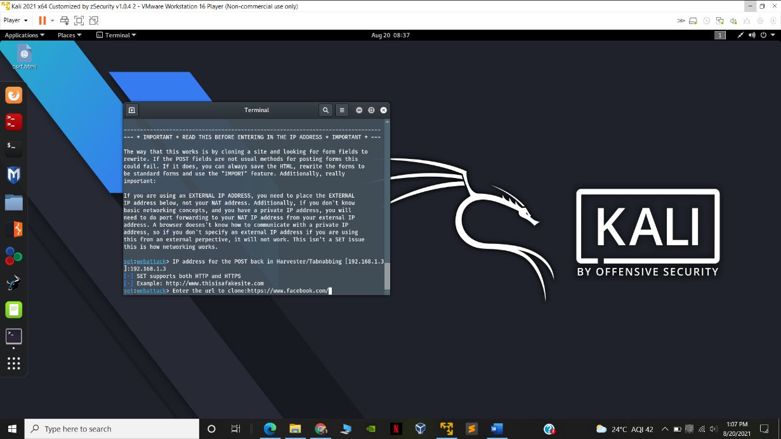

-it will clone the website !!

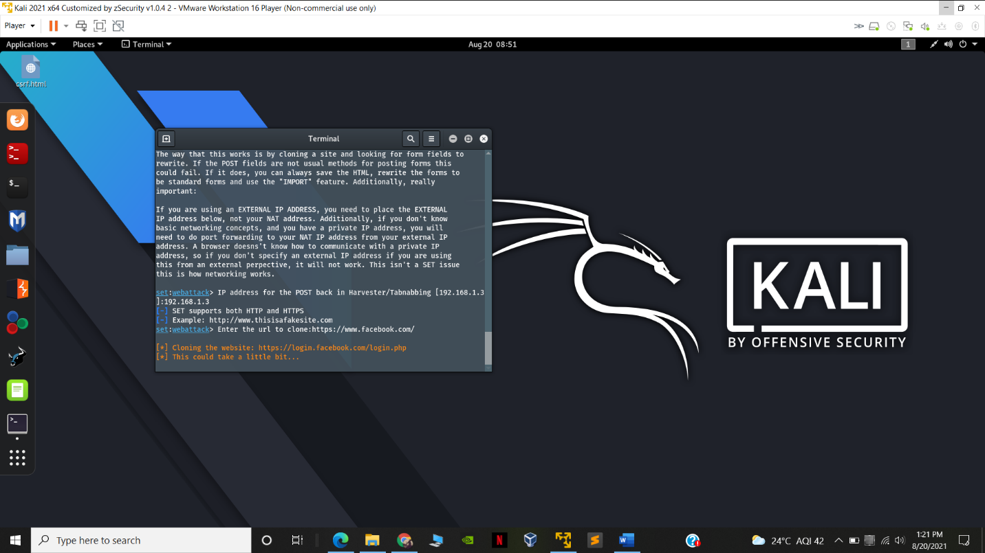

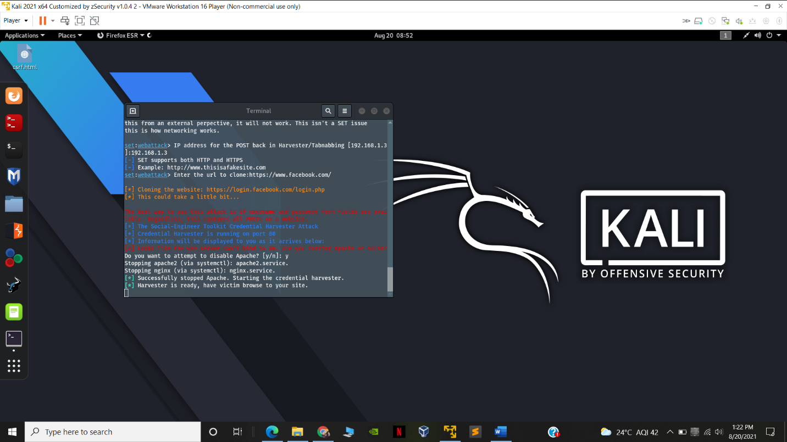

* Now we can go to 192.168.1.3 to get the cloned version of facbook !

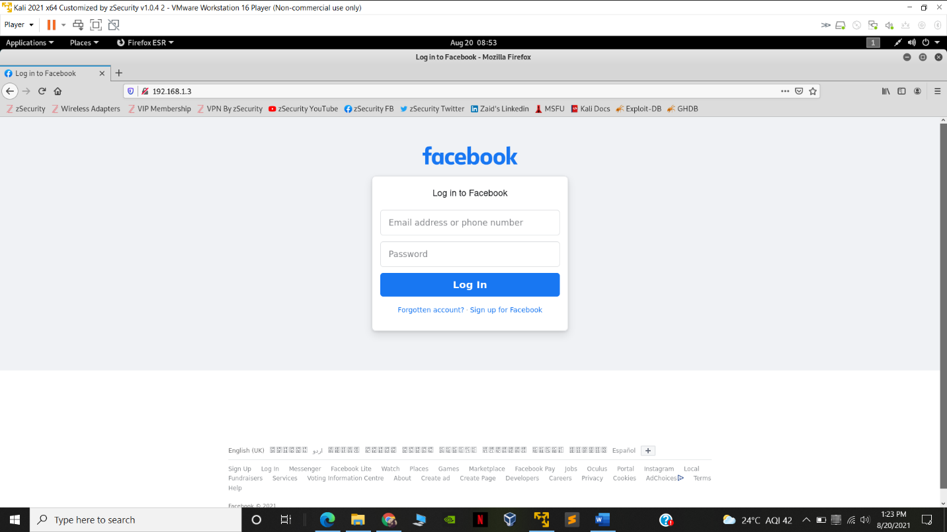

-enter the credentials

So the credentials are logged in the terminal so we got the victims credentials !!!

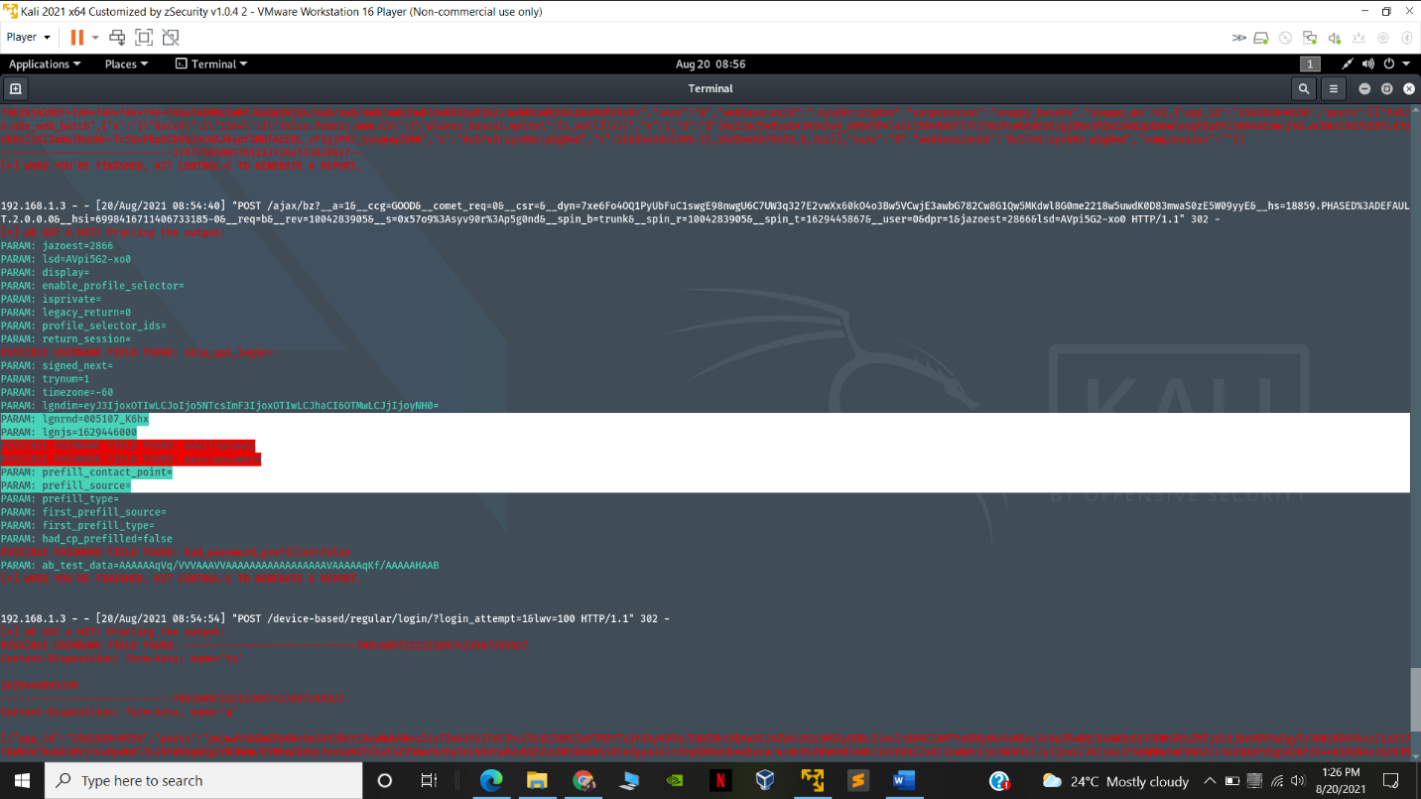

Thus we successfully cloned facebook page and got the credentials of the target !!!

**PREVENTIVE MEASURE TO AVOID PHISING ATTACKS ON YOURSELF :**

* Get free anti-phishing add-ons. ...
* Don't give your information to an unsecured site. Like on http ones ...
* Don't be tempted by those pop-ups
* Deploy a web filter to block malicious websites.
* Educate your employees and conduct training sessions with mock phishing scenarios.
* Deploy a SPAM filter that detects viruses, blank senders, etc.